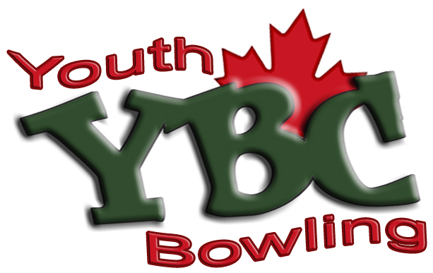
Supervised Learn to Bowl Program
for ages 3-19 (in peer teams)
Saturday Mornings @ 10:00am
Starting Sept. 6th, 2025

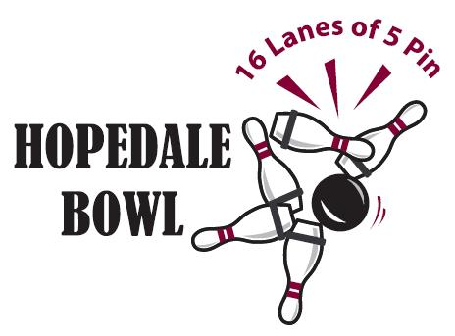
Registration Fee
$100.00

Weekly Fee
Ages 4-7 (Peewee Division)
2 Games - $9.50
Ages 8-19 (Bantam, Junior & Senior Divisions)
3 Games - $13.00

Includes:
1 Free Game Every Month for 1 Year
Instruction from Qualified Coaches
Exciting Tournaments
Team Uniform
Achievement Crests
Year End Party and Awards Presentation
Practice games anytime throughout the season for $4.50 per player

Come out and make lifelong friendships!
Call 905-827-4281 for further information

Never miss a game:
Bowlers have the option of bowling in advance to “bank their scores” in case of absences. This protects perfect attendance!
Pre-Bowling is subject to lane availability

Not sure if it’s for you?
Come bowl with us for 2 weeks and try it out for free. (No registration commitment required until the 3rd week)
Valid for New Bowlers only.

